Bahria University,

Karachi Campus



Course: CEL-220 – Computer Architecture & Logic Design

Term: Spring 2021, Class: BSE- 3(B)

Submitted By:

**M Muaz Shahzad 02-131202-081**

(Name) (Reg. No.)

Submitted To:

Engr. Dr. Samar Yazdani/Engr. Ramsha Mashood

Signed Remarks: Score:

INDEX

|  |  |  |  |  |
| --- | --- | --- | --- | --- |
| SNO | DATE | LAB NO | LAB OBJECTIVE | SIGN |
| 01 | 13-10-21 | 01 | Introduction of assembly language. |  |
| 02 | 27-10-21 | 02 | Conditional statements. |  |
|  |  |  |  |  |
|  |  |  |  |  |
|  |  |  |  |  |
|  |  |  |  |  |
|  |  |  |  |  |
|  |  |  |  |  |
|  |  |  |  |  |
|  |  |  |  |  |
|  |  |  |  |  |
|  |  |  |  |  |
|  |  |  |  |  |
|  |  |  |  |  |
|  |  |  |  |  |
|  |  |  |  |  |
|  |  |  |  |  |
|  |  |  |  |  |
|  |  |  |  |  |
|  |  |  |  |  |

Bahria University,

Karachi Campus



LAB EXPERIMENT NO.

**01**

LIST OF TASKS

|  |  |
| --- | --- |
| TASK NO | OBJECTIVE |
| 01 | **To take input and subtract** |
| 02 | **To take two input as hardcore and add them** |
|  |  |
|  |  |
|  |  |
|  |  |
|  |  |
|  |  |
|  |  |
|  |  |

Submitted On:

**28/10/21**

(Date: DD/MM/YY)

**TASK 1:EXAMPLE**

ADDITON

IN Input number to be added

ADD 99 Add value stored at address 99 to input

OUT Output result

HLT Halt (program ends here)

*99 Next value loaded at address 99

DAT -001 Data value

**

**TASK 2**: To take input and Subtract

IN Input number to be added

ADD 99 Add value stored at address 99 to input

OUT Output result

HLT Halt (program ends here)

*99 Next value loaded at address 99

DAT +001 Data value

**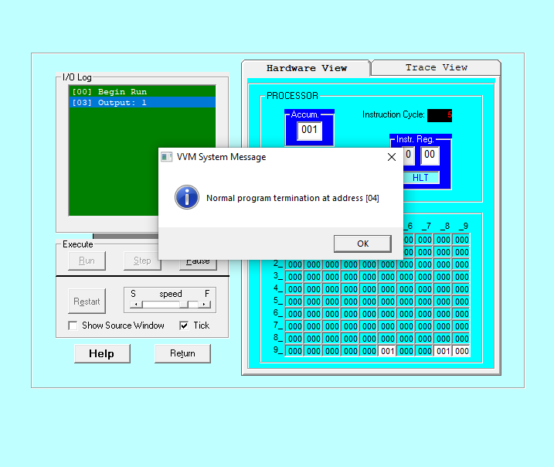

**TASK 3**: To take two input as hardcore and add them.

IN Input A

STO 98 Store A

IN Input B

STO 99 Store B

LDA 98 Load value of A

SUB 99 Subtract B from A

STO 97

OUT

HLT end

**

**TASK:4 EXAMPLE**

LDA 98

ADD 99

OUT

HLT

*98

DAT 005

*99

DAT 006

**

Bahria University,

Karachi Campus

LAB EXPERIMENT NO.

**02**

LIST OF TASKS

|  |  |
| --- | --- |
| TASK NO | OBJECTIVE |
| 01 | **Take any integer as input, if the number is greater than 5 print it If a>5, print a Else if a=0,then Halt Else if a.** |
| 02 | **Take two numbers as input and print the larger number** |
|  |  |
|  |  |
|  |  |
|  |  |
|  |  |
|  |  |
|  |  |
|  |  |

Submitted On:

**28/10/21**

(Date: DD/MM/YY)

**TASK 1: EXAMPLE**

IN Input to be added

sto 99

lda 99

sub 98

BRP 05

OUT Output reuslt

HLT

*98

DAT 005

**

**TASK 2: Example**

IN

sto 98

IN

sto 99

lda 98

sub 99

BRP 11

LDA 99

SUB 98

STO 97

BR 14

LDA 98

ADD 99

STO 97

OUT Output reuslt

HLT

TASK 3: Example**

IN

sto 98

IN

sto 99

lda 98

sub 99

BRP 09

HLT

BR 14

LDA 98

SUB 99

STO 97

OUT Output reuslt

HLT

**OUTPUT:**

**TASK 4:** Take any integer as input, if the number is greater than 5 print it If a>5, print a Else if a=0,then Halt Else if a.

IN

sto 98

lda 98

sub 99

BRZ 09

BRP 07

BR 09

LDA 98

OUT

HLT

*99

DAT 005

TASK 5 : Example**

IN

sto 98

IN

STO 99

LDA 98

SUB 99

BRP 11

BR 08

LDA 99

OUT

HLT

LDA 98

OUT

HLT

**